1. **Write a program to create barplots for all the categorical columns in mtcars.**

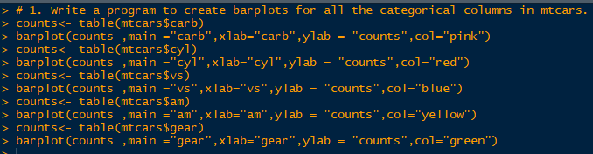

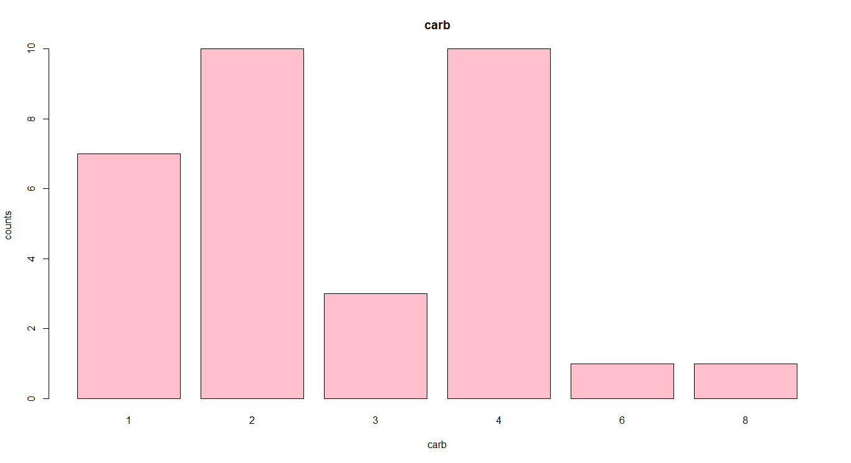

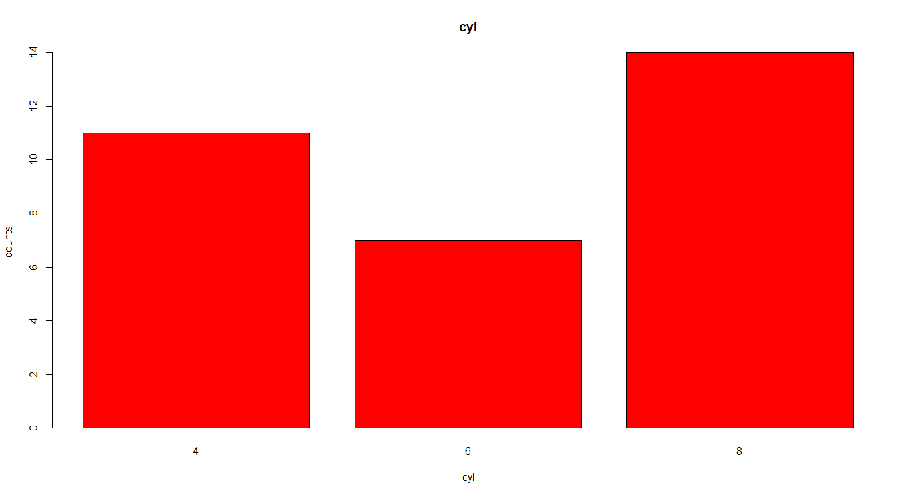

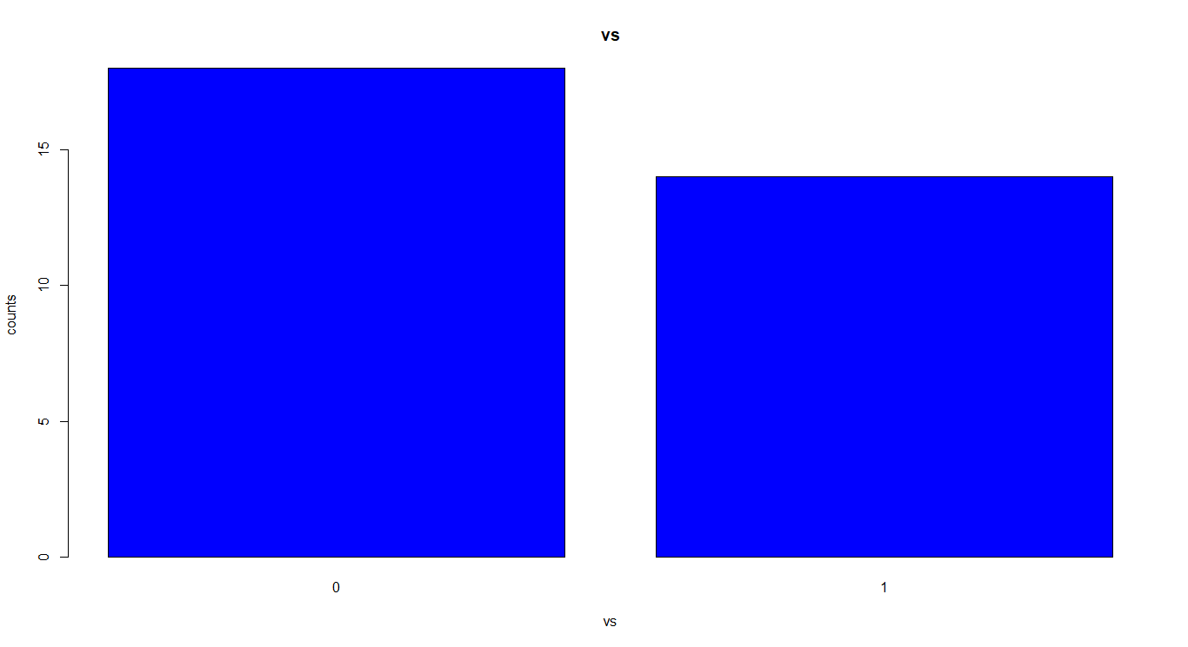

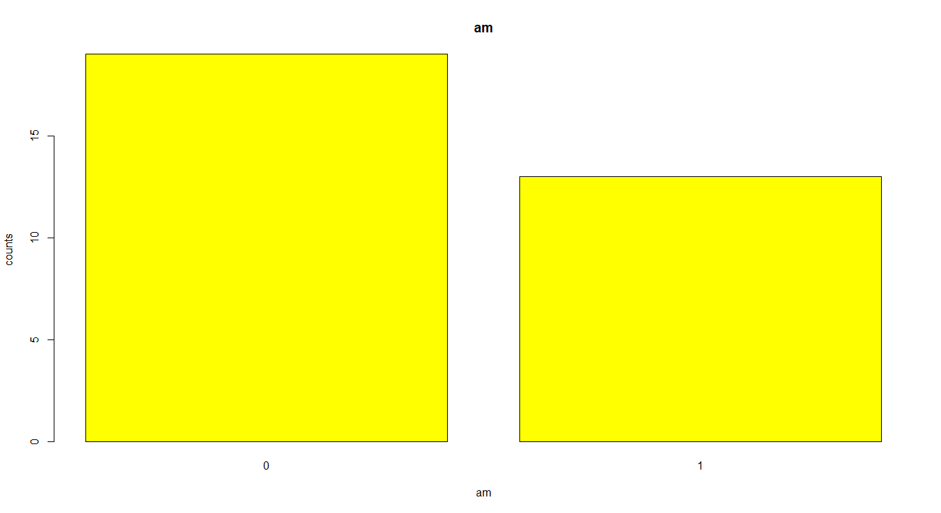

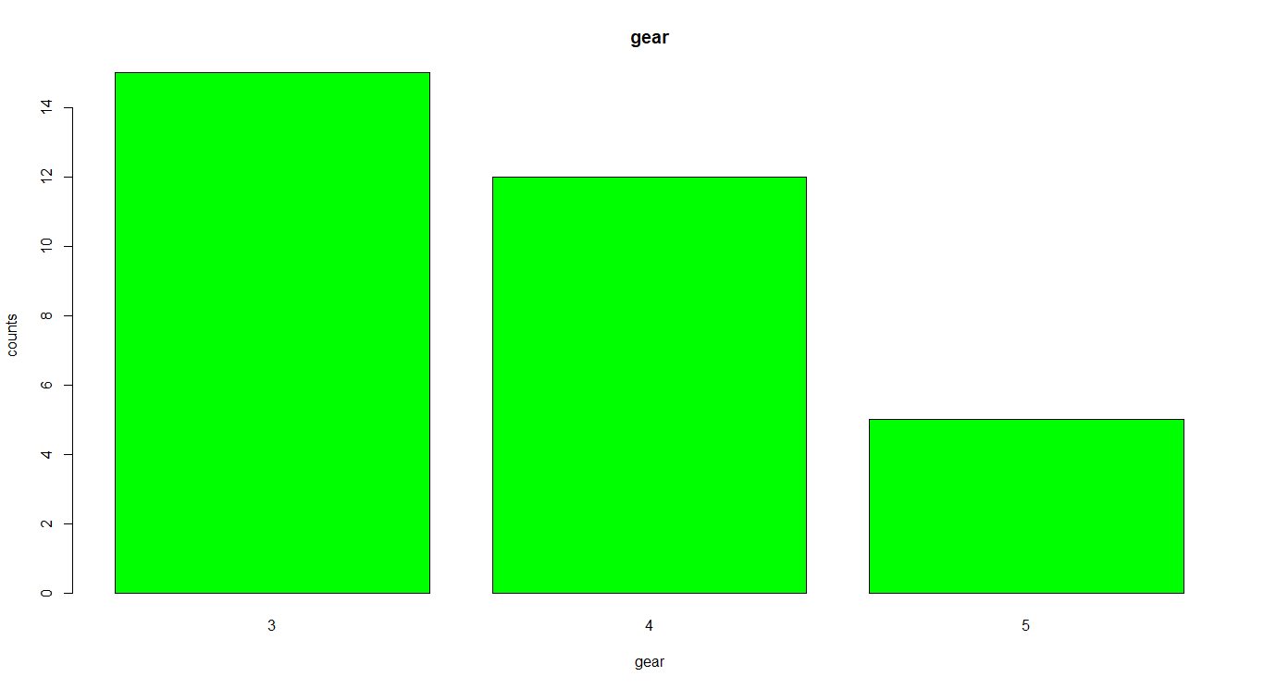

1. **Create a scatterplot matrix by gear types in mtcars dataset.**

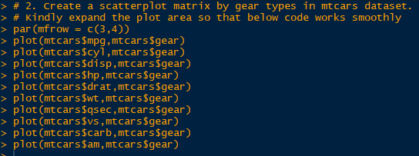

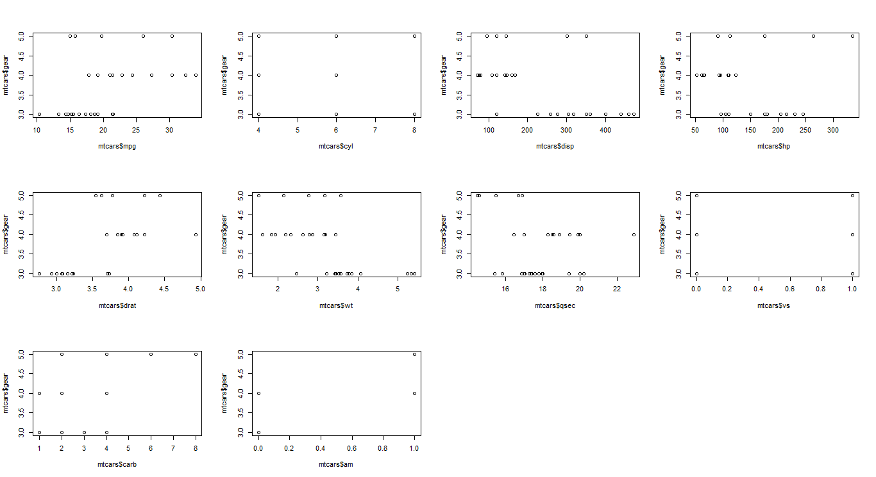

1. **Write a program to create a plot density by class variable.**

C:\Users\SIMATIT\Desktop\Data-Analytics Assignments\7.2 EX 3.1.png

